EEE 120

Capstone Design Project
Name:______Thien Tran____________________
Instructor:___Steven Millman____________________
Class Time:___Tu/Thu 3:00PM - 4:15PM____________________
Date:____May 1, 2025____________________

Task C-1: Planning the Synchronous Sequential Machines
(5 pts) Interview at least 3 stakeholders, but 3 is preferred. Ask questions regarding the form, function, and features needed by potential customers for this design. Make sure to capture what the customer prefers from this type of solution, as well as what environment the customer plans to use this design. Summarize your findings here and document the names of who you interviewed.
I interviewed the following stakeholders to gather requirements and preferences for the traffic light controller design:
- Tam Nguyen (Computer Science Major): Tam underlined the necessity of having clear visual signals that indicate the state of the traffic signal. According to him, safety elements should come first, and he recommended using different timing patterns for different traffic situations.
- Huy Nguyen (Electrical Engineering Major): Huy noted the significance of reducing the number of parts while preserving complete functioning.
- Mike Nguyen (Family): As a driver, Mike highlighted the frustration with poorly timed traffic lights. They suggested having longer green light durations for the main street during high traffic periods and emphasized the value of having a clear "all-red" safety interval.
(5 pts) Please include a comment on why your automation adds value from multiple perspectives (technological, societal, financial, environmental, etc.). (What value does this add? What is the type of customer for whom this is designed? Where is this most needed? What couldn’t you do before?)
Technological: Using synchronous sequential machines that can handle multiple operation modes.
Societal: Improving commute times and reducing driver frustration, while the safety features (such as proper timing between light changes) prevent accidents.
Financial: More cost-effective to maintain than mechanical systems and can be easily reprogrammed for different traffic patterns without hardware changes.
Environmental: Reducing idle time for vehicles, therefore decreasing fuel consumption and emissions.

(5 pts) It is allowable to continue to ask questions of stakeholders throughout the design process (and is preferred of a conscientious engineer). This can be done as you are designing, before you are designing if you need input and clarifications, or after you are done designing if you want feedback on improvements. Summarize any changes to your understanding or design based on the feedback you received during your initial interviews or continual interviews?
Based on the feedback received during interviews, I made several modifications to my initial understanding:
- Creating all-red intervals between any transition from green to red for Design 2, as safety was mentioned as a top priority.
- For C = 11 mode, I implemented a “rush hour” mode for Design 1 where we are able to stay at the current state. More specifically, Main Street or Side Avenue gets a longer green light duration, based on Mike’s feedback.
- To compare whether a simpler design can function just as well as a more complex one, I created two designs, one of which is simpler than the other.

Task C-2: Document the Synchronous Sequential Machines
Design #1: (2 pts) What assumptions did you make in the design of this machine?
- Normal operation (C=00) cycles through the traditional Red-Green-Yellow sequence.
- Flashing modes (C=01 and C=10) alternate between on and off states at regular intervals.
- For C=11, the system implements a "rush hour" mode.
- All transitions between green and red states must go through yellow for safety.
(3 pts) Create a state definition table here that describes in plain English what each state in your machine means and what binary values you have assigned to represent each state, inputs, and outputs.
State | Binary Representation  (Q2 Q1 Q0) | Output  (MG, MY, MR, SG, SY, SR) | Description
S0 | 000 | 100001 | Main: Green, Side: Red
S1 | 001 | 010001 | Main: Yellow, Side: Red
S2 | 010 | 001100 | Main: Red, Side: Green
S3 | 011 | 001010 | Main: Red, Side: Yellow
S4 | 100 | 001001 | Both Red
S5 | 101 | 000000 | Turn off (For flashing mode)

(12 pts) Show your state diagrams, state transition tables and your circuit planning work (Karnaugh maps/equations/MUX/DEC/etc.) used in your design process. (You can do this by hand if you wish, do not show the full circuit schematic here.)
State Diagram:
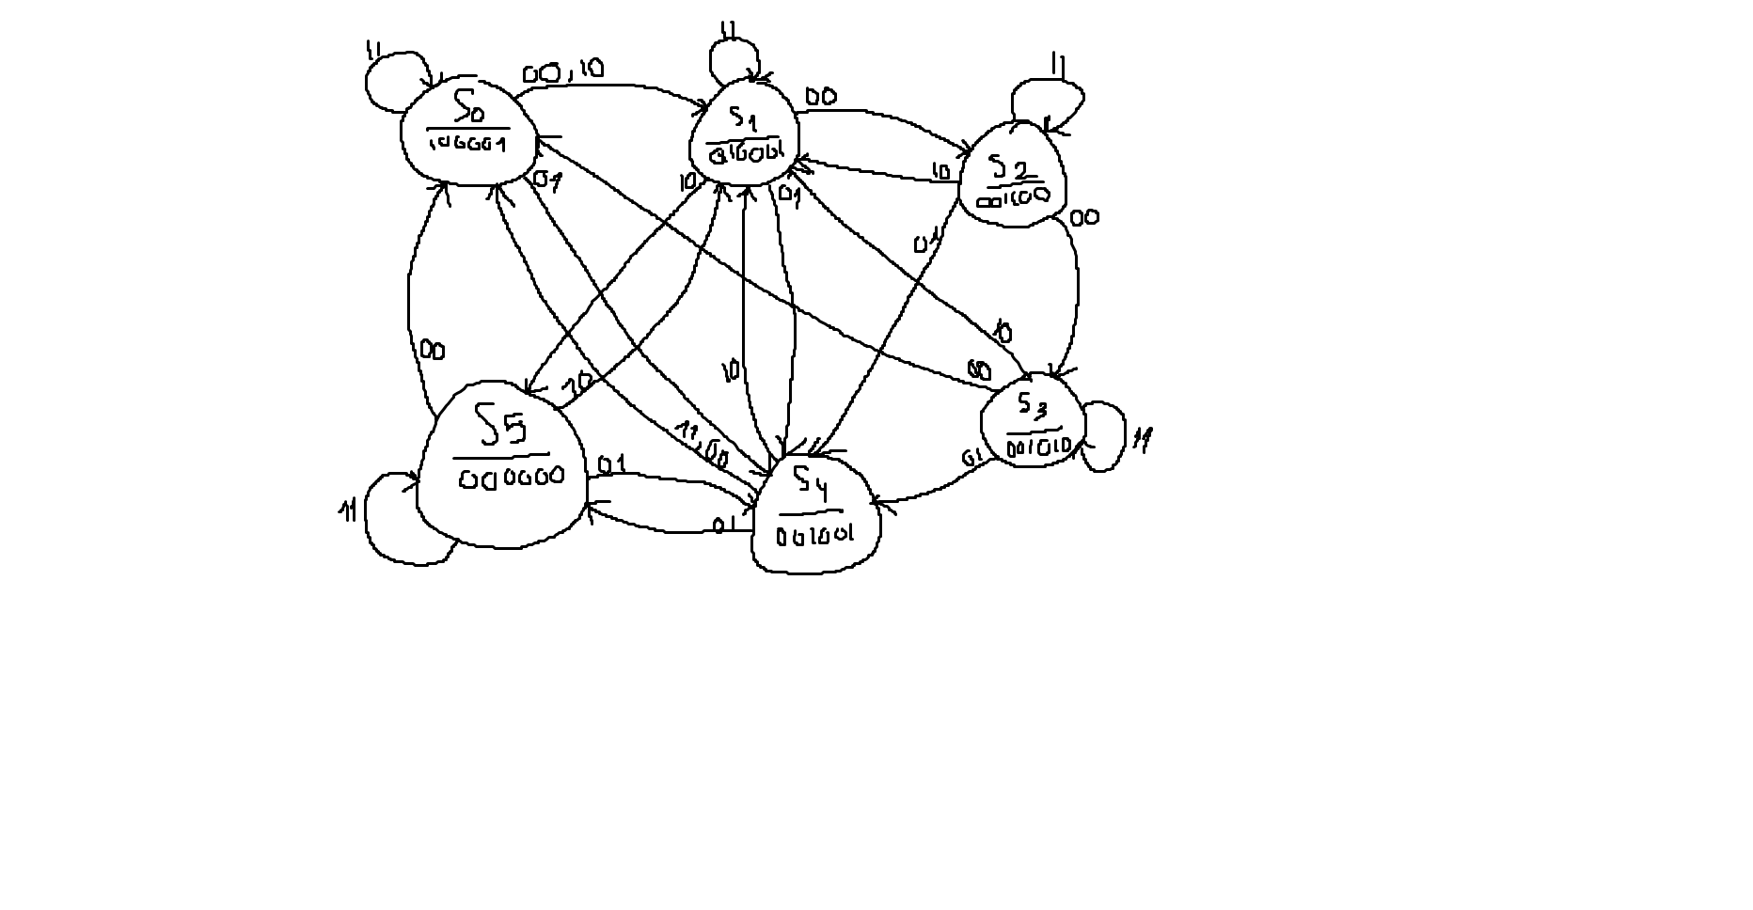
State Transition Table:
Q2 | Q1 | Q0 | C1 | C0 | Q2' | Q1' | Q0' | MG | MY | MR | SG | SY | SR
0 | 0 | 0 | 0 | 0 | 0 | 0 | 1 | 1 | 0 | 0 | 0 | 0 | 1
0 | 0 | 0 | 0 | 1 | 1 | 0 | 0 | 1 | 0 | 0 | 0 | 0 | 1
0 | 0 | 0 | 1 | 0 | 0 | 0 | 1 | 1 | 0 | 0 | 0 | 0 | 1
0 | 0 | 0 | 1 | 1 | 0 | 0 | 0 | 1 | 0 | 0 | 0 | 0 | 1
0 | 0 | 1 | 0 | 0 | 0 | 1 | 0 | 0 | 1 | 0 | 0 | 0 | 1
0 | 0 | 1 | 0 | 1 | 1 | 0 | 0 | 0 | 1 | 0 | 0 | 0 | 1
0 | 0 | 1 | 1 | 0 | 1 | 0 | 1 | 0 | 1 | 0 | 0 | 0 | 1
0 | 0 | 1 | 1 | 1 | 0 | 0 | 1 | 0 | 1 | 0 | 0 | 0 | 1
0 | 1 | 0 | 0 | 0 | 0 | 1 | 1 | 0 | 0 | 1 | 1 | 0 | 0
0 | 1 | 0 | 0 | 1 | 1 | 0 | 0 | 0 | 0 | 1 | 1 | 0 | 0
0 | 1 | 0 | 1 | 0 | 0 | 0 | 1 | 0 | 0 | 1 | 1 | 0 | 0
0 | 1 | 0 | 1 | 1 | 0 | 1 | 0 | 0 | 0 | 1 | 1 | 0 | 0
0 | 1 | 1 | 0 | 0 | 0 | 0 | 0 | 0 | 0 | 1 | 0 | 1 | 0
0 | 1 | 1 | 0 | 1 | 1 | 0 | 0 | 0 | 0 | 1 | 0 | 1 | 0
0 | 1 | 1 | 1 | 0 | 0 | 0 | 1 | 0 | 0 | 1 | 0 | 1 | 0
0 | 1 | 1 | 1 | 1 | 0 | 1 | 1 | 0 | 0 | 1 | 0 | 1 | 0
1 | 0 | 0 | 0 | 0 | 0 | 0 | 0 | 0 | 0 | 1 | 0 | 0 | 1
1 | 0 | 0 | 0 | 1 | 1 | 0 | 1 | 0 | 0 | 1 | 0 | 0 | 1
1 | 0 | 0 | 1 | 0 | 0 | 0 | 1 | 0 | 0 | 1 | 0 | 0 | 1
1 | 0 | 0 | 1 | 1 | 0 | 0 | 0 | 0 | 0 | 1 | 0 | 0 | 1
1 | 0 | 1 | 0 | 0 | 0 | 0 | 0 | 0 | 0 | 0 | 0 | 0 | 0
1 | 0 | 1 | 0 | 1 | 1 | 0 | 0 | 0 | 0 | 0 | 0 | 0 | 0
1 | 0 | 1 | 1 | 0 | 0 | 0 | 1 | 0 | 0 | 0 | 0 | 0 | 0
1 | 0 | 1 | 1 | 1 | 1 | 0 | 1 | 0 | 0 | 0 | 0 | 0 | 0

Karnaugh maps:
Q2+:
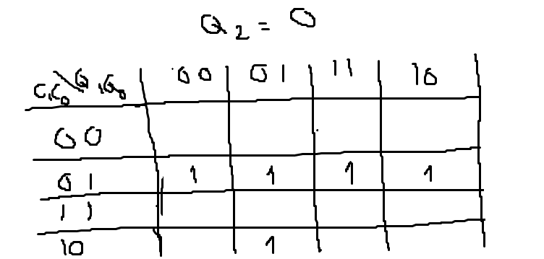
Q1+:
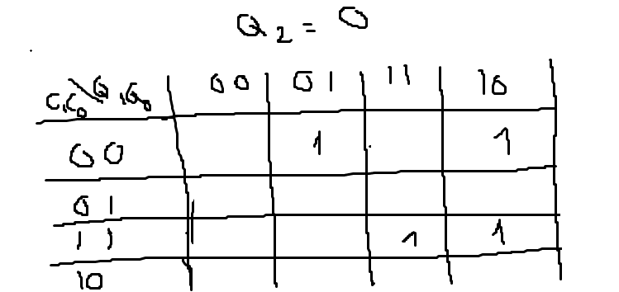
Q0+:
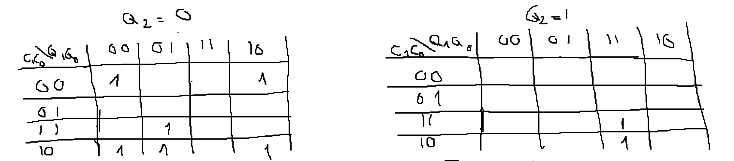
MG:
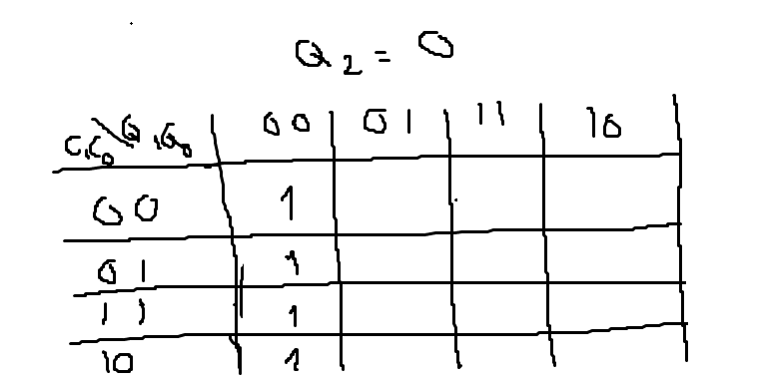
MY:
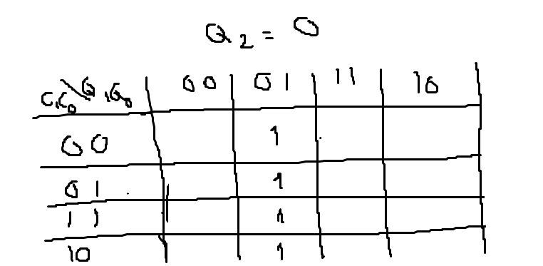
MR:
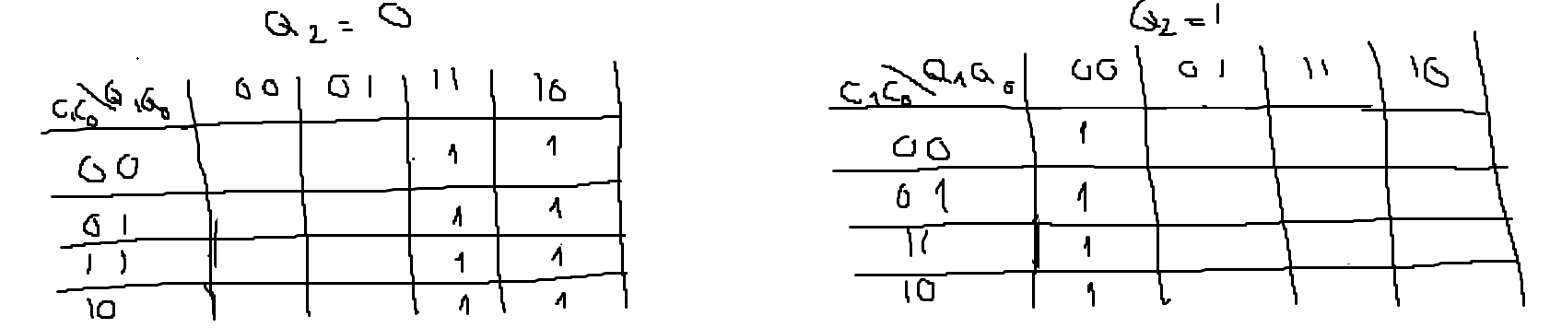
SG:
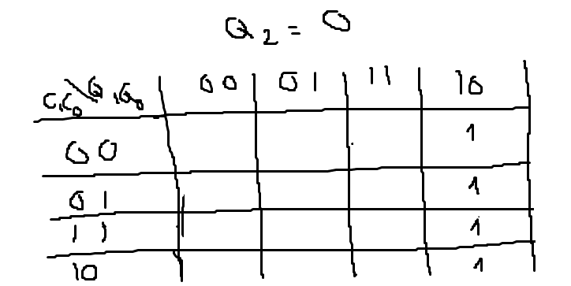
SY:
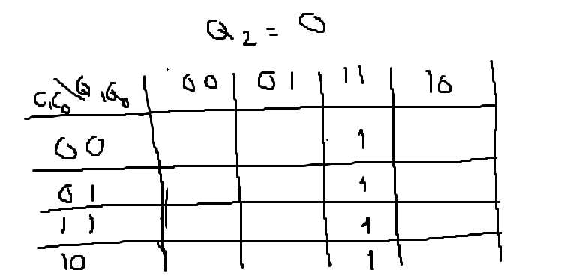
SR:
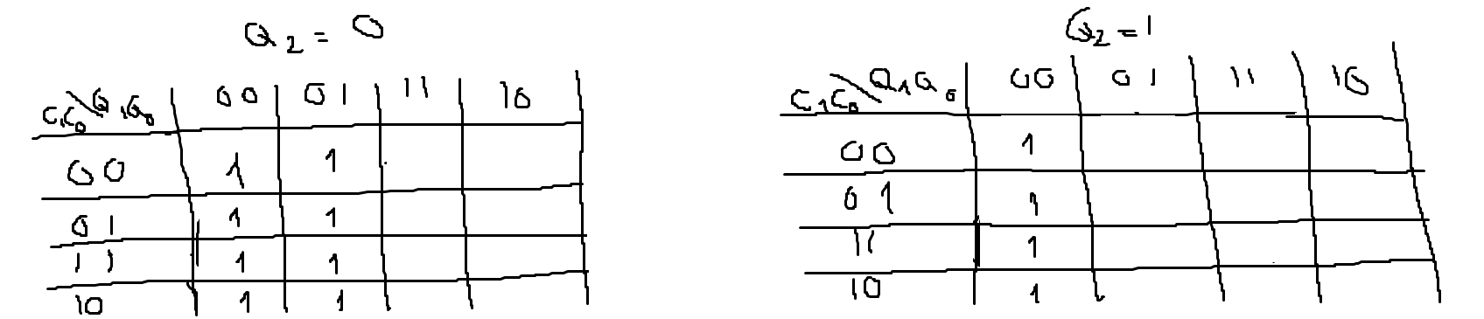
(3 pts) List your final design equations and required logic gates (including types of Flip Flops) needed to complete this circuit.
Q2+ = Q2’C1’C0 + Q1’Q0’C1’C0 + Q2Q1’Q0C0 + Q2’Q1’Q0C1C0’
Q1+ = Q2’C1’C0’(Q1’Q0 + Q1Q0’) + Q2’Q1C1C0
Q0+ = Q2’Q0’C0’ + Q2’Q0C1 + Q2Q1’C1C0’ + Q2Q1’Q0’C1 + Q2Q1’Q0’C1’C0
MG = Q2’Q1’Q0’
MY =Q2’Q1’Q0
MR = Q2’Q1 + Q2Q1’Q0’
SG = Q2’Q1Q0’
SY = Q2’Q1Q0
SR =Q2’Q1’ + Q1’Q0’
Required logic gates:
20 AND Gates
5 OR Gates
1 XOR Gate
2 NOT Gates
3 D-Flip-flops with asynchronous set/reset
Design #2: (2 pts) What assumptions did you make in the design of this machine?
- Safety is the top priority - all transitions from red to green include an all-red state.
- Normal operation (C=00) follows a strict Red-Green-Yellow-Red sequence.
- Flashing modes (C=01 and C=10) alternate between on and off at equal intervals.
- For C=11, the system implements a "night mode" with yellow blinking on both streets.
(3 pts) Create a state definition table here that describes in plain English what each state in your machine means and what binary values you have assigned to represent each state.
State | Binary Representation  (Q2 Q1 Q0) | Output  (MG, MY, MR, SG, SY, SR) | Description
S0 | 000 | 100001 | Main: Green, Side: Red
S1 | 001 | 010001 | Main: Yellow, Side: Red
S2 | 010 | 001001 | Main: Red, Side: Red before Side turning Green
S3 | 011 | 001100 | Main: Red, Side: Green
S4 | 100 | 001010 | Main: Red, Side: Yellow
S5 | 101 | 001001 | Main: Red, Side: Red before Main turning Green
S6 | 110 | 010010 | Yellow flashing mode
S7 | 111 | 000000 | Turn off (For flashing mode)

(12 pts) Show your state diagrams, state transition tables and your circuit planning work (Karnaugh maps/equations/MUX/DEC/etc.) used in your design process. (You can do this by hand if you wish, do not show the full circuit schematic here.)
State Diagram:
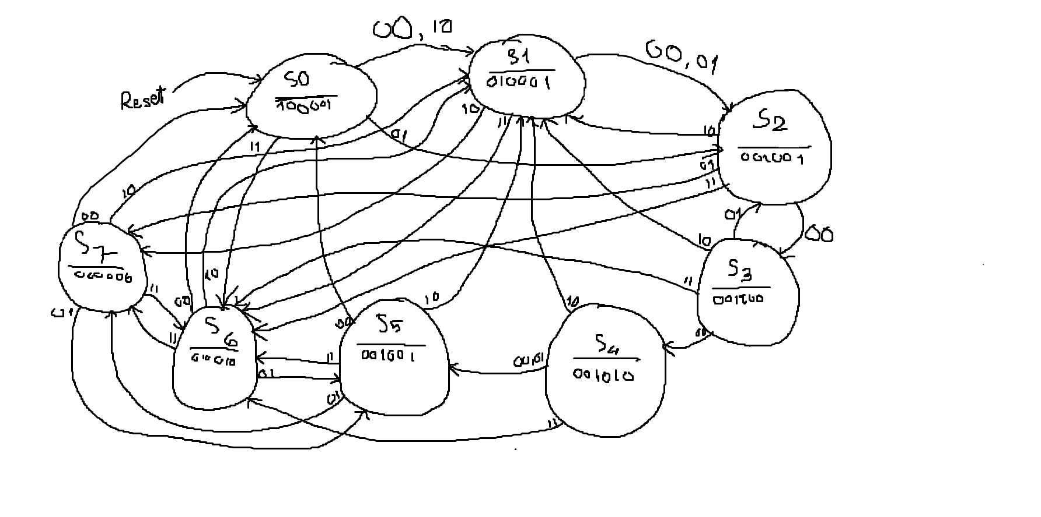
State Transition Table:
Q2 | Q1 | Q0 | C1 | C0 | Q2’ | Q1’ | Q0’ | MG | MY | MR | SG | SY | SR
0 | 0 | 0 | 0 | 0 | 0 | 0 | 1 | 1 | 0 | 0 | 0 | 0 | 1
0 | 0 | 0 | 0 | 1 | 0 | 1 | 0 | 1 | 0 | 0 | 0 | 0 | 1
0 | 0 | 0 | 1 | 1 | 1 | 1 | 0 | 1 | 0 | 0 | 0 | 0 | 1
0 | 0 | 0 | 1 | 0 | 0 | 0 | 1 | 1 | 0 | 0 | 0 | 0 | 1
0 | 0 | 1 | 0 | 0 | 0 | 1 | 0 | 0 | 1 | 0 | 0 | 0 | 1
0 | 0 | 1 | 0 | 1 | 0 | 1 | 0 | 0 | 1 | 0 | 0 | 0 | 1
0 | 0 | 1 | 1 | 1 | 1 | 1 | 0 | 0 | 1 | 0 | 0 | 0 | 1
0 | 0 | 1 | 1 | 0 | 1 | 1 | 1 | 0 | 1 | 0 | 0 | 0 | 1
0 | 1 | 0 | 0 | 0 | 0 | 1 | 1 | 0 | 0 | 1 | 0 | 0 | 1
0 | 1 | 0 | 0 | 1 | 1 | 1 | 1 | 0 | 0 | 1 | 0 | 0 | 1
0 | 1 | 0 | 1 | 1 | 1 | 1 | 0 | 0 | 0 | 1 | 0 | 0 | 1
0 | 1 | 0 | 1 | 0 | 0 | 0 | 1 | 0 | 0 | 1 | 0 | 0 | 1
0 | 1 | 1 | 0 | 0 | 1 | 0 | 0 | 0 | 0 | 1 | 1 | 0 | 0
0 | 1 | 1 | 0 | 1 | 0 | 1 | 0 | 0 | 0 | 1 | 1 | 0 | 0
0 | 1 | 1 | 1 | 1 | 1 | 1 | 0 | 0 | 0 | 1 | 1 | 0 | 0
0 | 1 | 1 | 1 | 0 | 0 | 0 | 1 | 0 | 0 | 1 | 1 | 0 | 0
1 | 0 | 0 | 0 | 0 | 1 | 0 | 1 | 0 | 0 | 1 | 0 | 1 | 0
1 | 0 | 0 | 0 | 1 | 1 | 0 | 1 | 0 | 0 | 1 | 0 | 1 | 0
1 | 0 | 0 | 1 | 1 | 1 | 1 | 0 | 0 | 0 | 1 | 0 | 1 | 0
1 | 0 | 0 | 1 | 0 | 0 | 0 | 1 | 0 | 0 | 1 | 0 | 1 | 0
1 | 0 | 1 | 0 | 0 | 0 | 0 | 0 | 0 | 0 | 1 | 0 | 0 | 1
1 | 0 | 1 | 0 | 1 | 1 | 1 | 1 | 0 | 0 | 1 | 0 | 0 | 1
1 | 0 | 1 | 1 | 1 | 1 | 1 | 0 | 0 | 0 | 1 | 0 | 0 | 1
1 | 0 | 1 | 1 | 0 | 0 | 0 | 1 | 0 | 0 | 1 | 0 | 0 | 1
1 | 1 | 0 | 0 | 0 | 0 | 0 | 0 | 0 | 1 | 0 | 0 | 1 | 0
1 | 1 | 0 | 0 | 1 | 1 | 0 | 1 | 0 | 1 | 0 | 0 | 1 | 0
1 | 1 | 0 | 1 | 1 | 1 | 1 | 1 | 0 | 1 | 0 | 0 | 1 | 0
1 | 1 | 0 | 1 | 0 | 0 | 0 | 1 | 0 | 1 | 0 | 0 | 1 | 0
1 | 1 | 1 | 0 | 0 | 0 | 0 | 0 | 0 | 0 | 0 | 0 | 0 | 0
1 | 1 | 1 | 0 | 1 | 1 | 0 | 1 | 0 | 0 | 0 | 0 | 0 | 0
1 | 1 | 1 | 1 | 1 | 1 | 1 | 0 | 0 | 0 | 0 | 0 | 0 | 0
1 | 1 | 1 | 1 | 0 | 0 | 0 | 1 | 0 | 0 | 0 | 0 | 0 | 0

Karnaugh Maps:
Q2+:
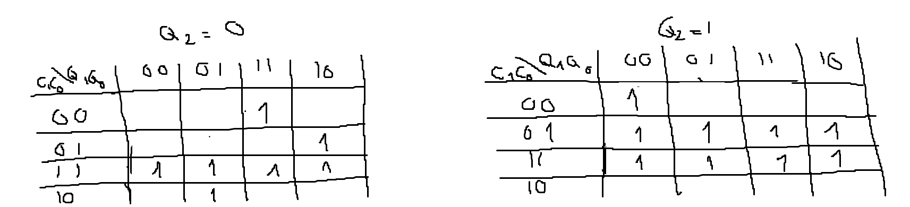
Q1+:
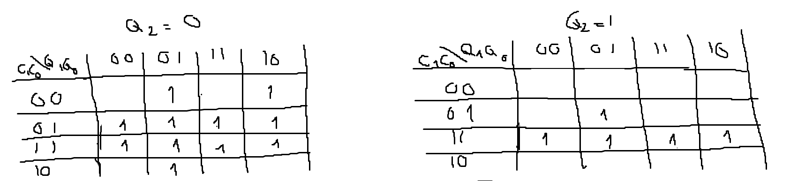
Q0+:
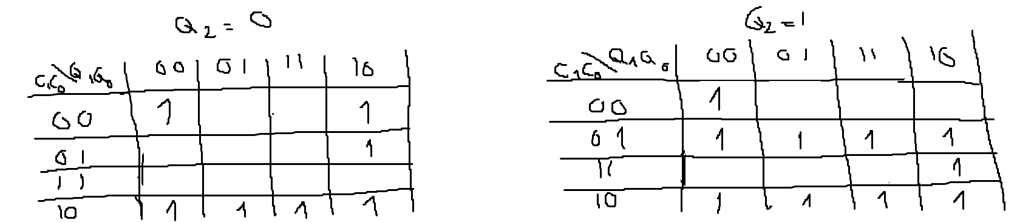
MG:

MY:
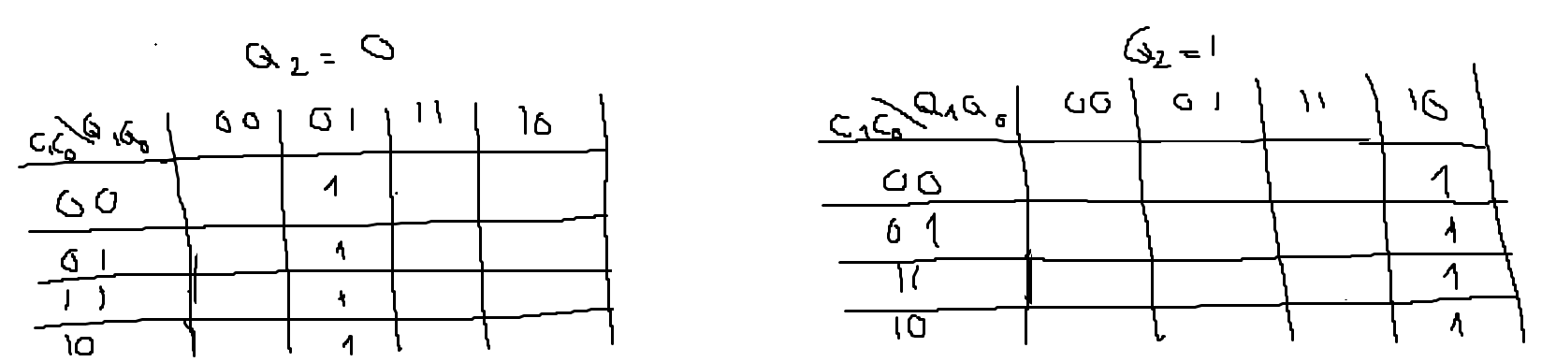
MR:
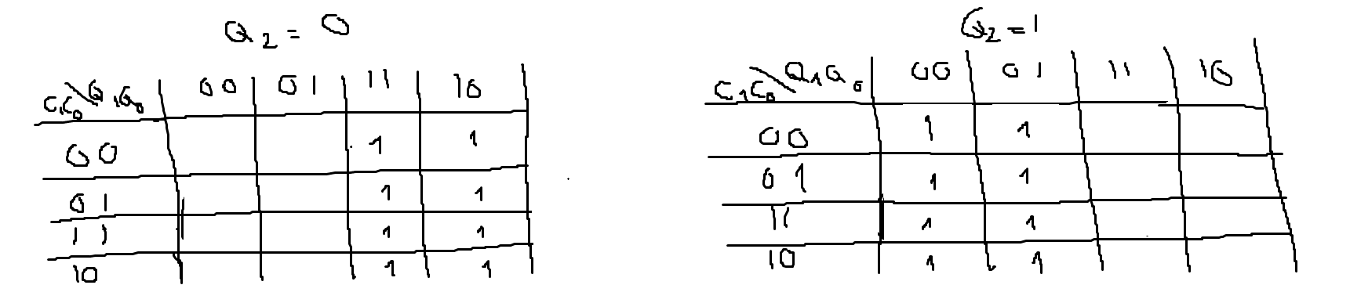
SG:

SY:
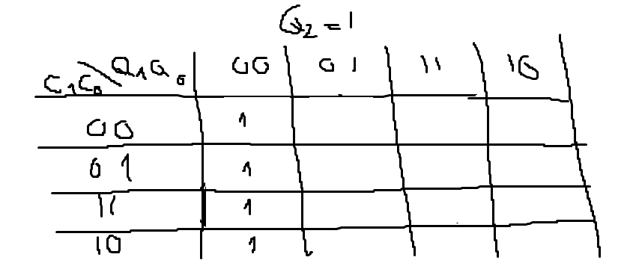
SR:
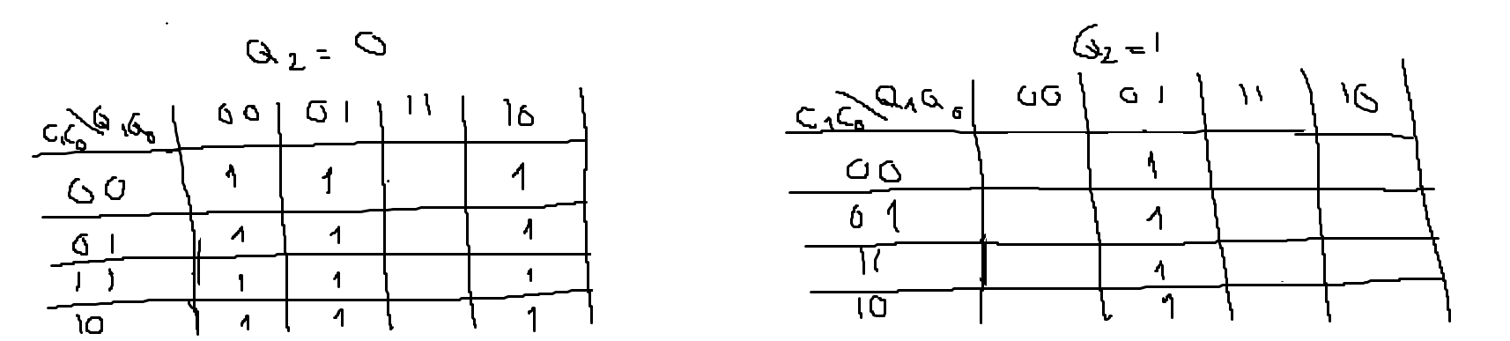
(3 pts) List your final design equations and required logic gates (including types of Flip Flops) needed to complete this circuit.
Q2+ = C1C0 + Q2’Q1’Q0C1 + Q2’Q1Q0C1’C0’ + Q1Q0’C0 + Q2Q1’Q0’C1’ + Q2C0
Q1+ = Q2’C0 + Q2’Q1’Q0 + Q2’Q1Q0’C1’ + C1C0 + Q1’Q0C0
Q0+ = Q2’Q0’C0’ + C1C0’ + Q2’Q1Q0’C1’ + Q2C1’C0 + Q2Q1’Q0’C1’ + Q2Q1Q0’C0
MG = Q2’Q1’Q0
MY = Q2’Q1’Q0 + Q2Q1Q0’
MR = Q2’Q1 + Q2Q1’
SG = Q2’Q1Q0
SY = Q2Q0’
SR = Q2’Q0’ + Q1’Q0
Required logic gates:
24 AND Gates
5 OR Gates
1 XOR Gate
2 NOT Gates
3 D-Flip-flops with asynchronous set/reset

Task C-3: Determine Criteria and Weighting for Judging Your Designs
(5 pts) Using the guidelines in the laboratory FAQ’s, list your 5 criteria and associated weights here used to help decide between the two design models (weights should add to 100%):
Criteria Weight
Safety Features 35%
Circuit Complexity 25%
User Experience/Clarity 20%
Adaptability to Traffic Conditions 20%

Task C-4: Apply the Criteria to Pick the Best Design
(2 pts) Describe how you applied each of the criteria and weighting system in the above task to pick the best design. How did you choose these criteria (customer interviews, engineering preference)?
Safety Features: Design 2 scores higher (32/35) compared to Design 1 (25/35) because it implements mandatory all-red safety intervals between any green-to-red transitions and has better handling of edge cases.
Circuit Complexity: Based on the number of gates and flip-flops required, Design 1 scores slightly better (20/25) than Design 2 (17/25), as it requires fewer logic gates and has simpler state transitions.
User Experience/Clarity: The clear safety intervals in Design 2 make the light transitions more intuitive for drivers. Therefore, Design 2 scores slightly better (18/20) than Design 1 (15/20).
Adaptability to Traffic Conditions: Design 1 (18/20) rush hour mode seems more practical and adaptable than Design 2 (14/20).
(3 pts) Which design is better based on your criteria and weighting system and why? Please explain how the winning design scored in each category and why (the winning design does not need to score the highest in every category, but it does need to score higher overall when applying the criteria weights).
Based on the weighted criteria:
- Design 1: (32 × 0.35) + (17 × 0.25) + (18 × 0.2) + (14 × 0.2) = 21.85
- Design 2: (25 × 0.35) + (20 × 0.25) + (15 × 0.2) + (18 × 0.15) = 20.35
Design 2 scores higher overall with 21.85 points versus 20.35 points for Design 1. While Design 1 has advantages in circuit complexity and adaptability to traffic conditions, Design 2's superior safety features and better user experience make it the better choice.

Task C-5: Build and Simulate Winning Design in Digital
(15 pts) Insert a copy of your chosen Digital Schematic here. Please make sure that you have outputs or tunnels connected to each flip flop so that you can easily monitor your states. Make sure that the logic and equations match the final equations presented in either Design 1 or Design 2.
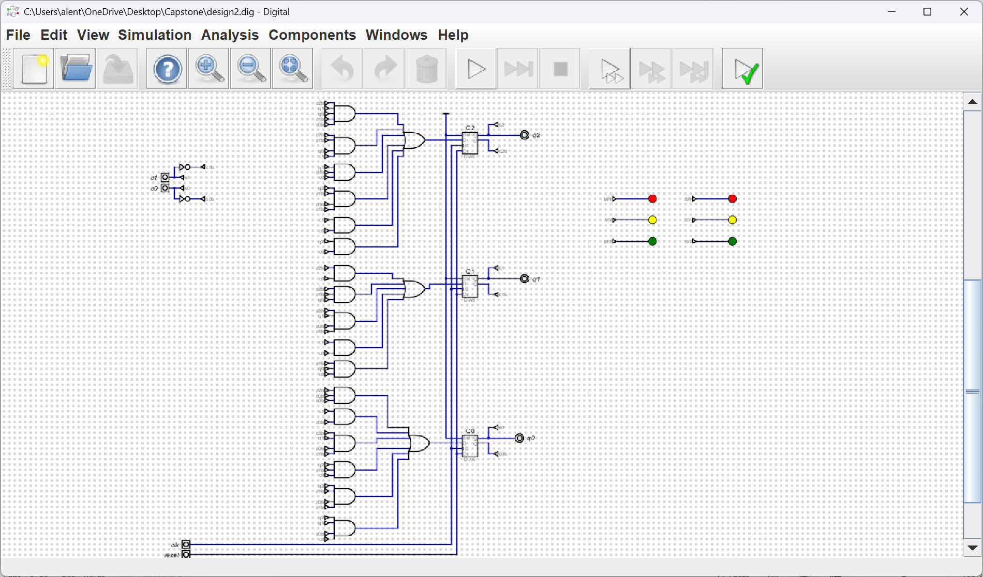
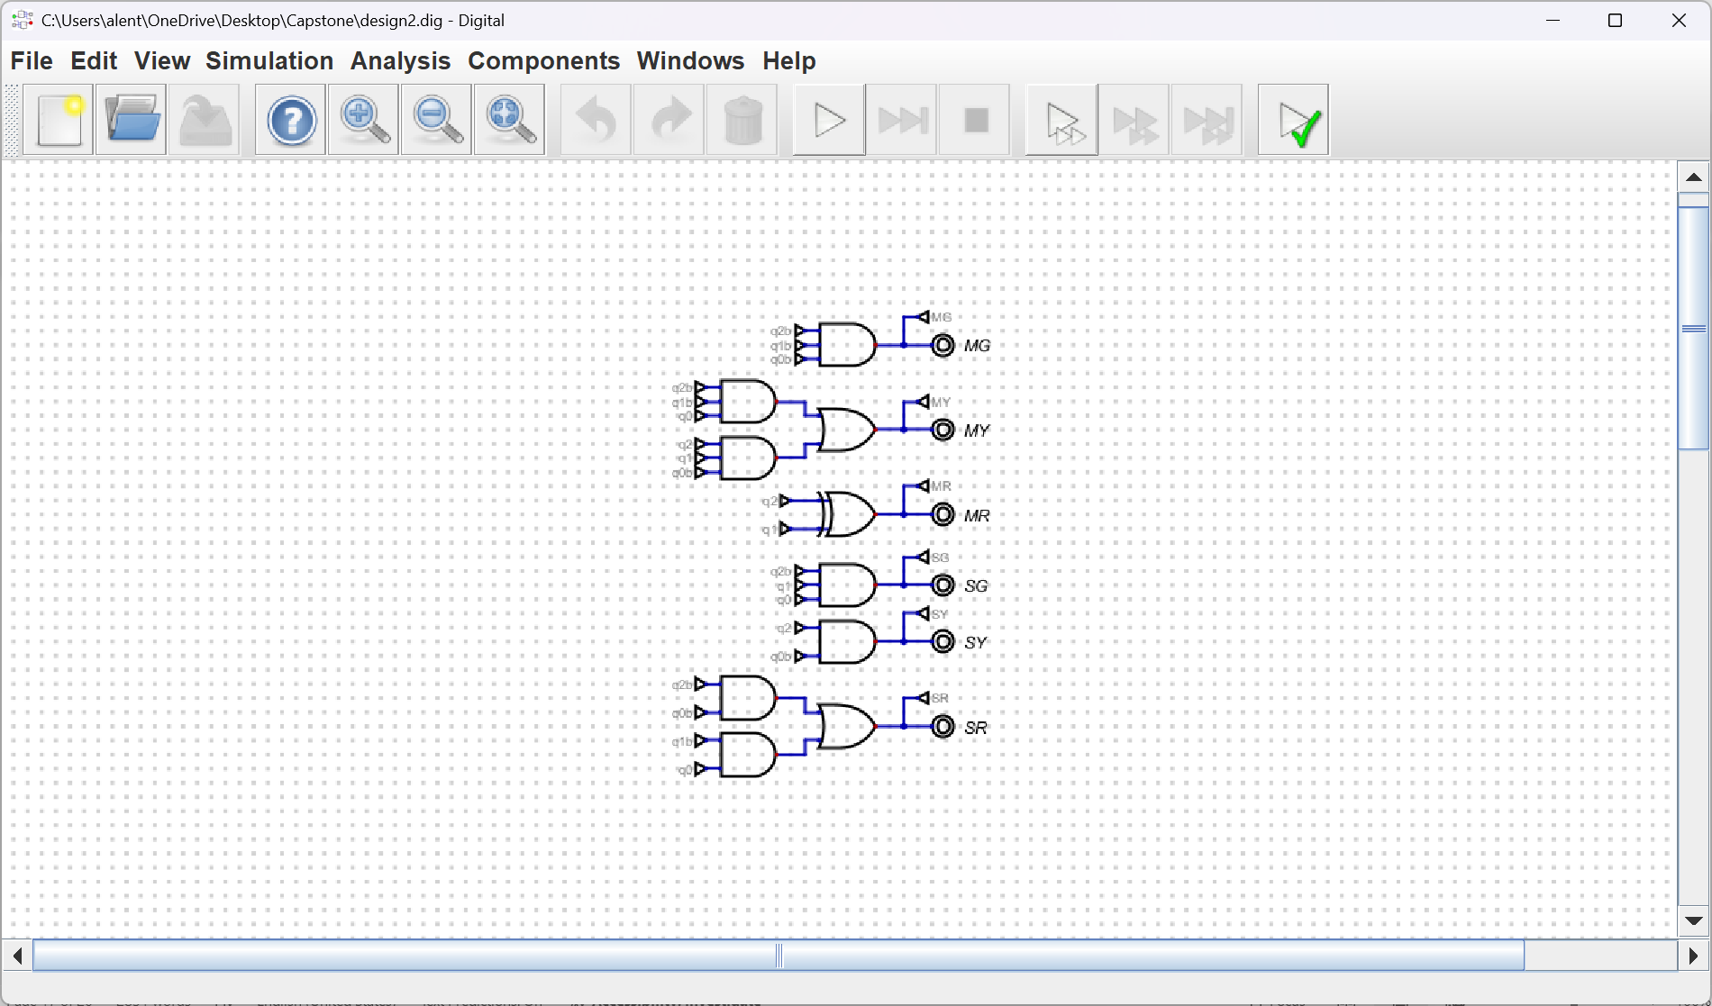

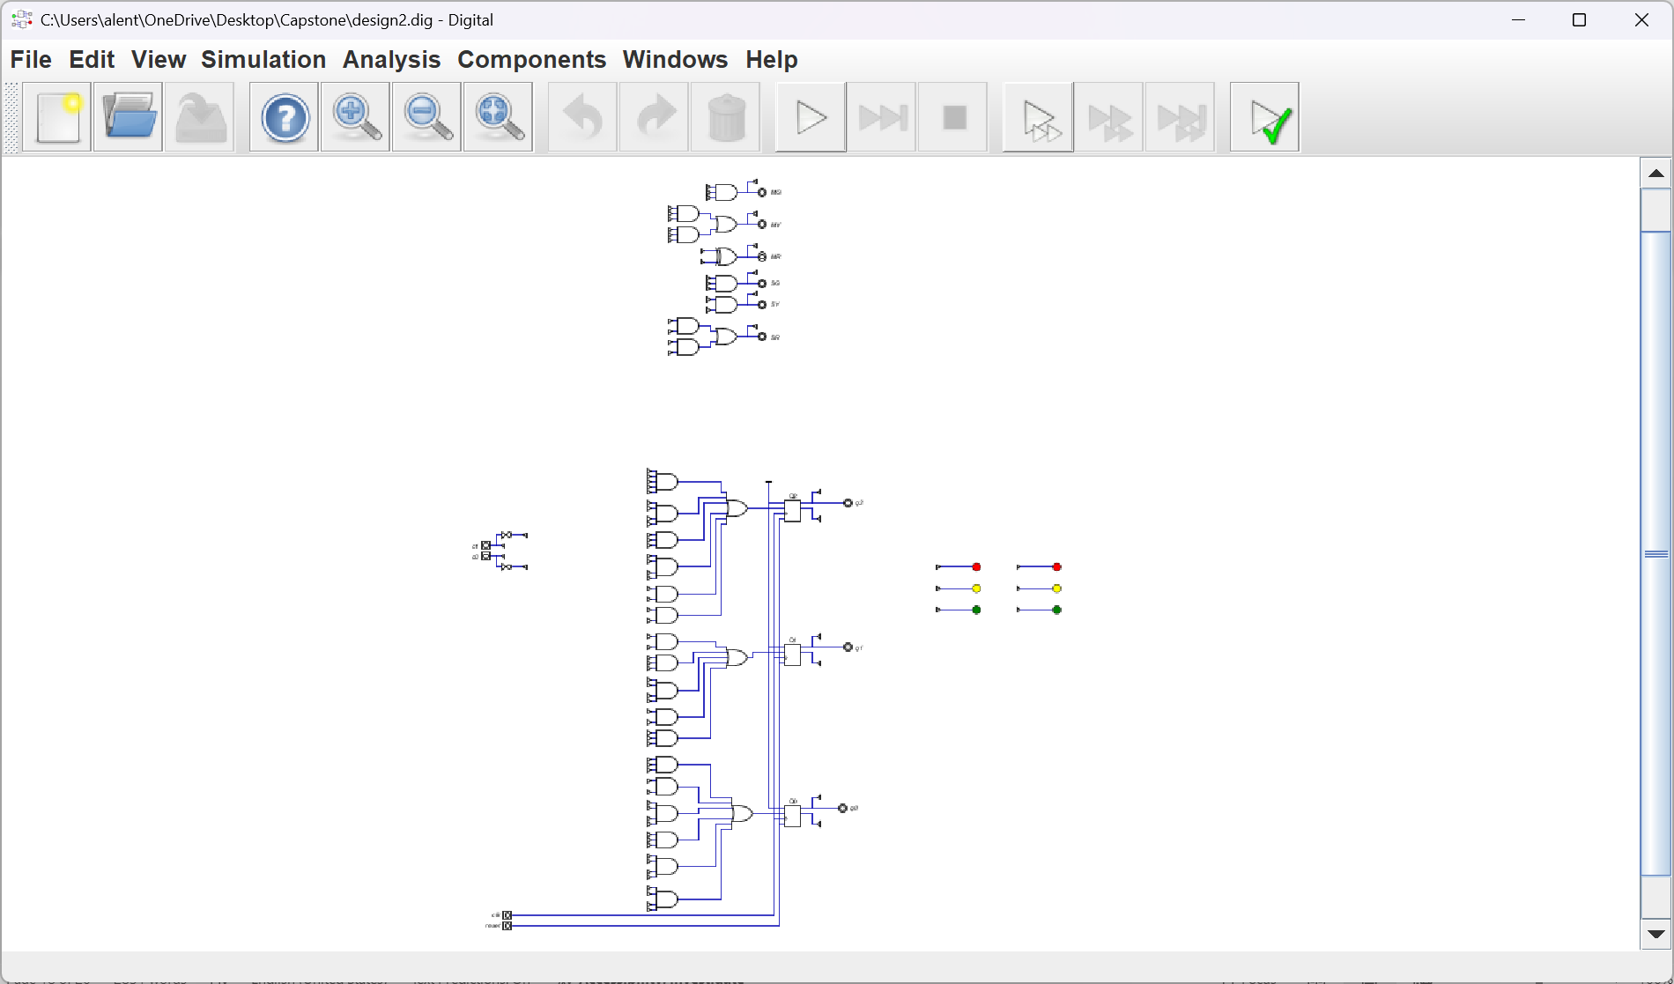

Task C-6: Record a Video Demonstration of the Winning Design
(15 pts) Record a video demonstration showing all positions being visited and various combinations of the inputs in Digital. For every clock cycle, explain the inputs, what current state you are in, and point out any outputs that should be noted. Be sure to show what happens for different input combinations at each position. That is, your demonstration should be able to showcase all possible states and transitions required to get there. If you include any asynchronous inputs, make sure to show those features as well. Add a link to your video below. Be sure to include any required password.
Video link: https://asu.zoom.us/rec/share/WV-MPxBy1yOP9j2_KuLw7KpPrK72jR7b6ieMBa60pCooG_bRB6D3ky4qoYLH5Ood.vxYFYtHeNUo5BF88
Passcode: h*9ZM7@q

Task C-7: Fill Out the Self-Assessment and Turn in Your Design
There are two items to submit. Turn in the zip file of your capstone project folder. Also turn in this template once it is filled out. There will be a deduction of 5 points if your template is only found inside the zip folder. The self-assessment is on the next page.

Self-Assessment Worksheet

Put an ‘X’ in the table below indicating how strongly you agree or disagree that the outcomes of the assigned tasks were achieved. Use ‘5’ to indicate that you ‘strongly agree’ and ‘1’ to indicate that you ‘strongly disagree’. Use ‘NA’, Not Applicable, when the tasks you performed did not elicit this outcome. Credit will be given for including this worksheet with your lab report. However, your responses will not be graded, they are for your instructor’s information only.
Table 1: Self-Assessment of Outcomes for the Capstone Design Project Lab.
After completing the assigned tasks and report I am able to: | 5 | 4 | 3 | 2 | 1 | NA
Initiate a design process based on a value proposition and feedback from various stakeholders. |  | X
Make assumptions to complete an incomplete functional specification. |  | X
Use classical design techniques (i.e., state diagrams, state transition tables, and Karnaugh Maps), to design a synchronous sequential machine starting with a functional specification. | X
Build, and debug a synchronous sequential machine. | X
Develop reasonable engineering criteria for comparing different designs. |  |  | X
Apply engineering criteria to select a ‘best’ design. |  |  | X

Write below any suggestions you have for improving this laboratory exercise so that the stated learning outcomes are achieved.

Capstone Design Project: Lab Report Grade Sheet

Name:

Grading Criteria | Max Points | Points lost
Template
Neatness, Clarity, and Concision | 5
Description of Assigned Tasks, Work Performed & Outcomes Met
Task C-1: Planning the Synchronous Sequential Machines | 15
Task C-2: Document the Synchronous Sequential Machines | 40
Task C-3: Determine Criteria and Weighting for Judging Your Designs | 5
Task C-4: Apply the Criteria to Pick the Best Design | 5
Task C-5: Build and Simulate Winning Design in Digital | 15
Task C-6: Record a Video Demonstration of the Winning Design | 15
Self-Assessment Worksheet (The content of the self-assessment worksheet will not be graded. Full credit is given for including the completed worksheet.) | (2 extra points)
 | Points Lost
Lab Score | Late Lab
 | Lab Score

